## -------------------Ultrasonic Sensor----------------

* What is an Ultrasonic Sensor?

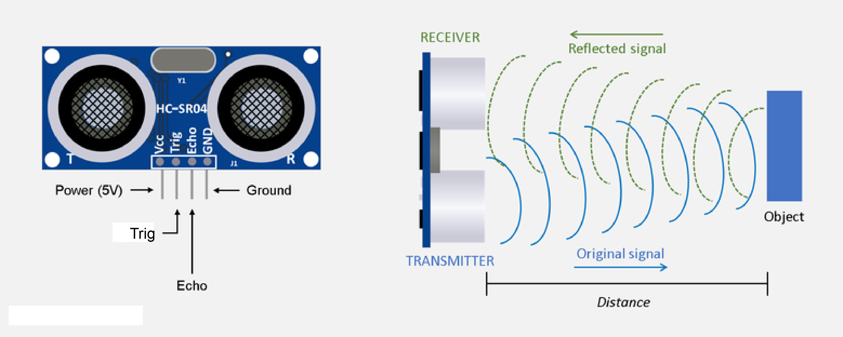

An **ultrasonic sensor** is a device that

Uses ultrasonic Sound waves to

Measure distance or detect objects.

It works by emitting high-frequency

Sound pulses (Typically above 20 kHz,

Beyond human hearing) and measuring the time it takes for

The echo to return after bouncing off an object.

* Working Of The Ultrasonic Sensor:

An ultrasonic sensor operates by emitting high-frequency sound waves, typically above 20 kHz, which are inaudible to humans. It consists of a transmitter that generates ultrasonic pulses and a receiver that detects the reflected sound waves. When the sensor sends out a pulse, the sound wave travels through the air until it encounters an object. Upon hitting the object, the wave bounces back toward the sensor. The sensor then measures the time taken for the echo to return. Using the formula Distance = (Speed of Sound × Time) / 2, the sensor calculates the distance to the object. The division by two accounts for the round-trip travel of the sound wave. The speed of sound in air is approximately 343 meters per second at room temperature, which helps in determining the precise distance. Ultrasonic sensors are widely used in robotics, automation, automotive parking systems, and industrial applications for object detection and distance measurement. They are effective in detecting obstacles and measuring levels of solids or liquids in tanks. However, they may struggle with soft or sound-absorbing materials like foam. Despite this limitation, their ability to function in various environments makes them a reliable choice for non-contact sensing applications.

* The Project:

The **obstacle-avoiding robot car** in the image operates using an **Arduino microcontroller**, an **ultrasonic sensor**, and **motor drivers**. The ultrasonic sensor, typically an **HC-SR04**, is mounted at the front and continuously emits ultrasonic pulses. These pulses travel forward, bounce off obstacles, and return to the sensor. The Arduino calculates the distance to the object using the time taken for the echo to return. If the distance falls below a predefined threshold (e.g., 10 cm), the Arduino triggers an avoidance maneuver. The robot's movement is controlled by **DC motors** connected to an **L298N motor driver**, which receives commands from the Arduino. When an obstacle is detected, the Arduino stops the forward motion and determines an alternate path by rotating the sensor or turning the wheels. Based on the sensor readings, it either moves left or right to avoid the obstacle. If no

Obstacle is detected, the robot continues moving forward. Power is supplied through a **battery pack**, and additional components like **servo motors** can be used to rotate the ultrasonic sensor for better detection. This type of robot is commonly used in robotics learning, automation, and autonomous navigation applications, demonstrating real-world obstacle avoidance techniques.

